

LONGFORD COUNTY COUNCIL

COMHAIRLE CHONTAE AN LONGFOIRT

Minutes of Special Meeting of Longford County Council
held in the Council Chamber, Aras an Chontae, Great Water Street, Longford on
Monday, 17th August 2015 at 4.00 p.m.

_______________________________________________________________________

PRESIDING: Councillor Gerry Warnock, Cathaoirleach.

MEMBERS PRESENT: Councillors – Paraic Brady, John Browne, Seamus Butler,
Mark Casey, Mick Cahill, Micheál Carrigy, John Duffy,
Padraig Loughrey, Martin Mulleady, Colm Murray,
Peggy Nolan, Pat O’Toole, Paul Ross and Mae Sexton.

IN ATTENDANCE: Mr. Barry Lynch, Deputy Chief Executive.
Deputies James Bannon, Robert Troy

APOLOGIES: Councillors Gerard Farrell, Luie McEntire, P.J.Reilly
Deputies Gabrielle McFadden, Willie Penrose

A/MEETINGS
ADMINISTRATOR: Ms. Mary Cooney.

Direct provision facilities in Longford town - accommodation for asylum seekers.

Councillor G. Warnock opened the meeting and thanked the Members and the Oireachtas Members for attending to discuss Direct Provision Facilities for Asylum Seekers in Longford. The meeting was convened because no formal notification was issued to the local authority to advise of the reopening of the Richmond Street hostel and he had been approached by residents of the local community requesting clarification on the issue.

An invitation issued to the Department of Justice asking a representative to attend the meeting to clarify some of the issues arising. The Reception Integration Agency (RIA) declined the invitation. The members unanimously agreed that the reluctance of the RIA to attend a meeting was highly discourteous to those elected to represent members of the public and did not accept that it would be inappropriate for a civil servant to attend a meeting to which they were invited.

The members acknowledged the humanitarian crisis currently unfolding in the Mediterranean resulting in an influx of migrants to Europe and praised the part that Ireland is playing in assisting migrants. Deputy Robert Troy cited that Ireland is in the top 5% of EU countries meeting its moral and social obligations where many EU countries have not taken in any refugees.

The content of the letter from the Reception Integration Centre (RIA) was discussed at length and the members agreed that Longford indeed has a strong tradition in welcoming asylum seekers. The members voiced their concerns that the Longford of 2000 is very different to the Longford of today, where unemployment is three times the national average and there is a social housing waiting list of over 1,200 applicants. Longford is designated as an “economically disadvantaged” county and Government Policy to place migrants in such locations hinders their future prospects, should their applications be successful.

It was noted that no Direct Provision Centres exist in some of the more affluent and growing counties such as South County Dublin, South East Ireland and Western counties and the members agreed that a more balanced integration programme needs to be developed for the country as a whole and one which would give migrants better access to employment opportunities should their applications be successful.

The members also asked why neither the Oireachtas members nor the local authority were informed of the reopening of the Centre on Richmond Street and what support mechanisms the RIA intend to put in place to support migrants while their applications are being processed.

The Deputy Chief Executive, Mr. B. Lynch confirmed to the meeting that the Local Authority had no formal notification of the reopening of the Centre on Richmond Street, therefore no fire safety inspection had been carried out before its occupation. However, a fire inspection has since been carried out on the building and no issues were found.

Mr. Lynch also informed the meeting that that those in Direct Provision facilities are not entitled to access social housing services. The RIA policy as stated on their website is that The distribution of asylum seekers in direct provision across Health Services Executive (HSE) areas indicate that in no case do the numbers exceed one third of 1% of the population of a HSE area. The processing of applications is done by a different agency with 12 to 13% being successful.

A detailed and lengthy discussion followed covering the following issues –

- Why the local authority or the Oireachtas members were not formally notified of the reopening of the Centre in Longford.

- What criteria the RIA use for the selection of locations and the selection of accommodation.

- That a more balanced integration system for the country as a whole be developed.

Deputy J. Bannon advised that he has raised a number of questions with the Minister in relation to the reopening of the Richmond Street Hostel and is awaiting answers. He also agreed that the country needs a better integration system that works.

The members requested that the Deputies ensure that their concerns are relayed directly to the Minister with responsibility for this area.

It was proposed by Councillor P. Nolan and seconded by Councillor G. Warnock that a Notice of Motion be raised at National Level that as Longford is designated as an “economically disadvantaged” area, it should be exempt from Direct Provision for asylum seekers.

In light of the content of the correspondence from the RIA and the concerns raised at the meeting in relation to the reopening of the Centre in Richmond Street, it was agreed that the Council again write to the RIA requesting clarification on a number of issues and that a response be forwarded in advance of the September Council meeting.

This concluded the business of the meeting.
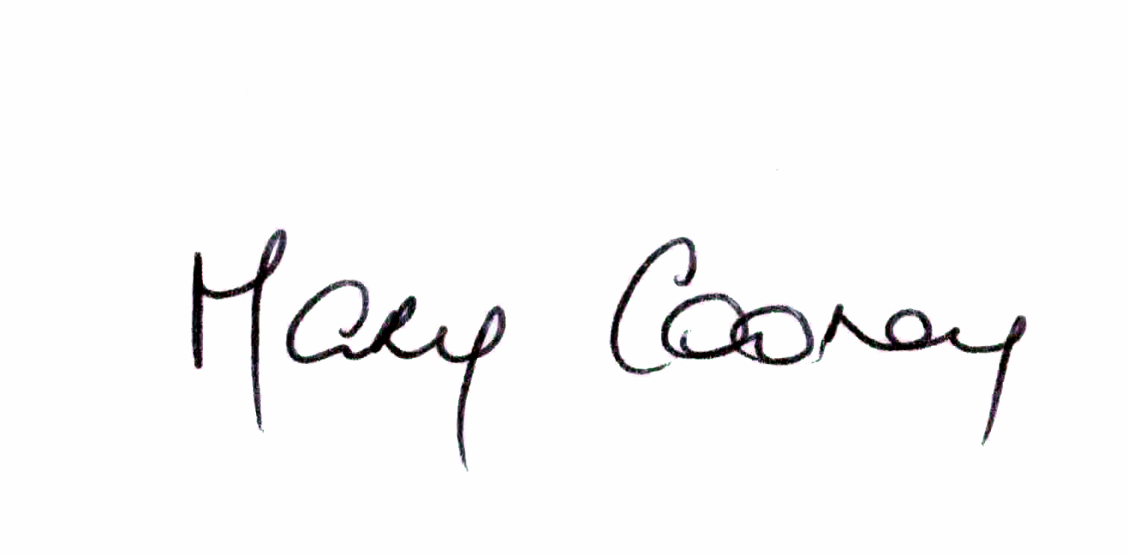

Signed: _______________
Mary Cooney,
A/ Meetings Administrator.

Confirmed and adopted at Monthly Meeting of Longford County Council held on the
9th September 2015.

Signed: _______________
Cathaoirleach.

